Ready for Proficiency - how to print ready-made tests?
- Open Assessment
- Click on Add assessment
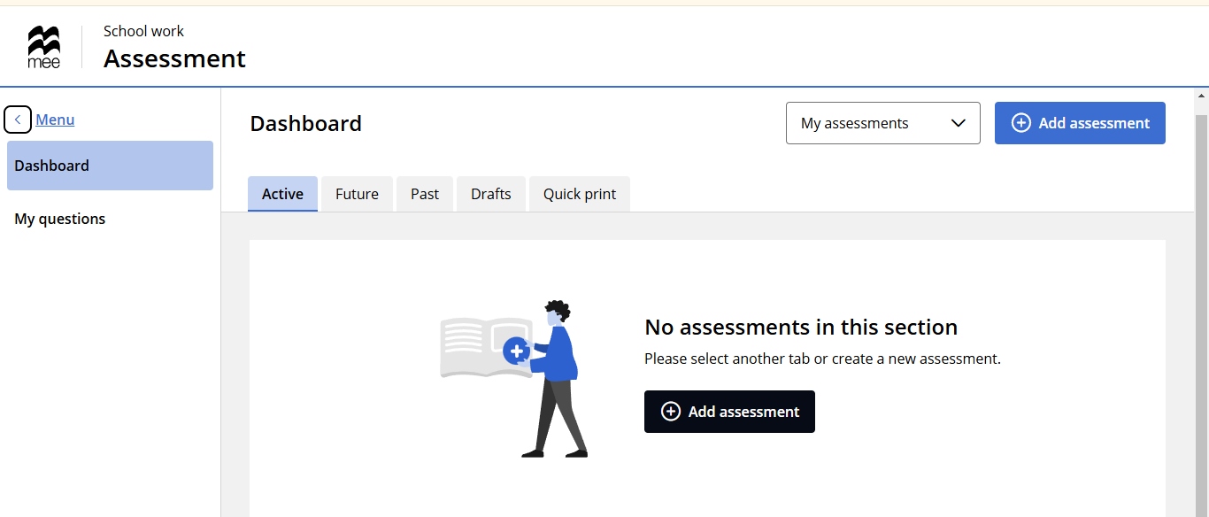
- Choose Paper (quick print)
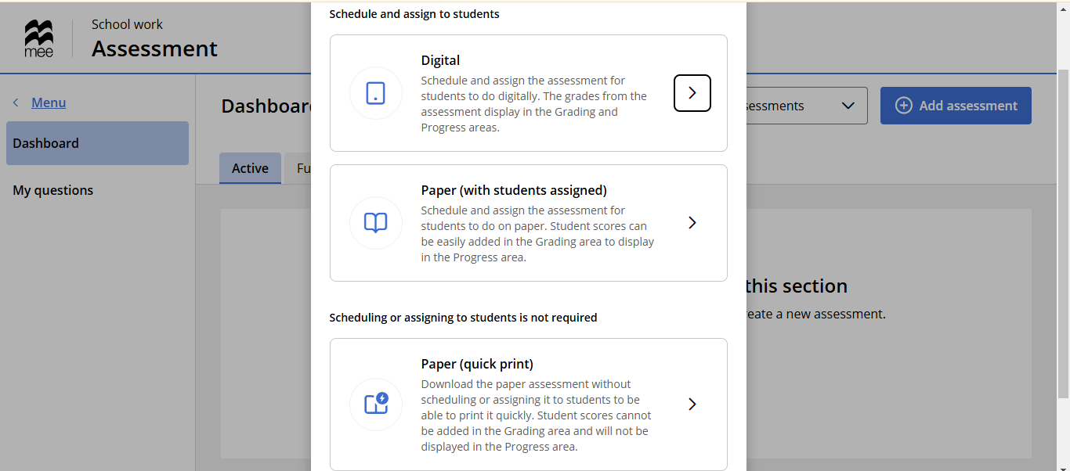

- Name the test and click on Save
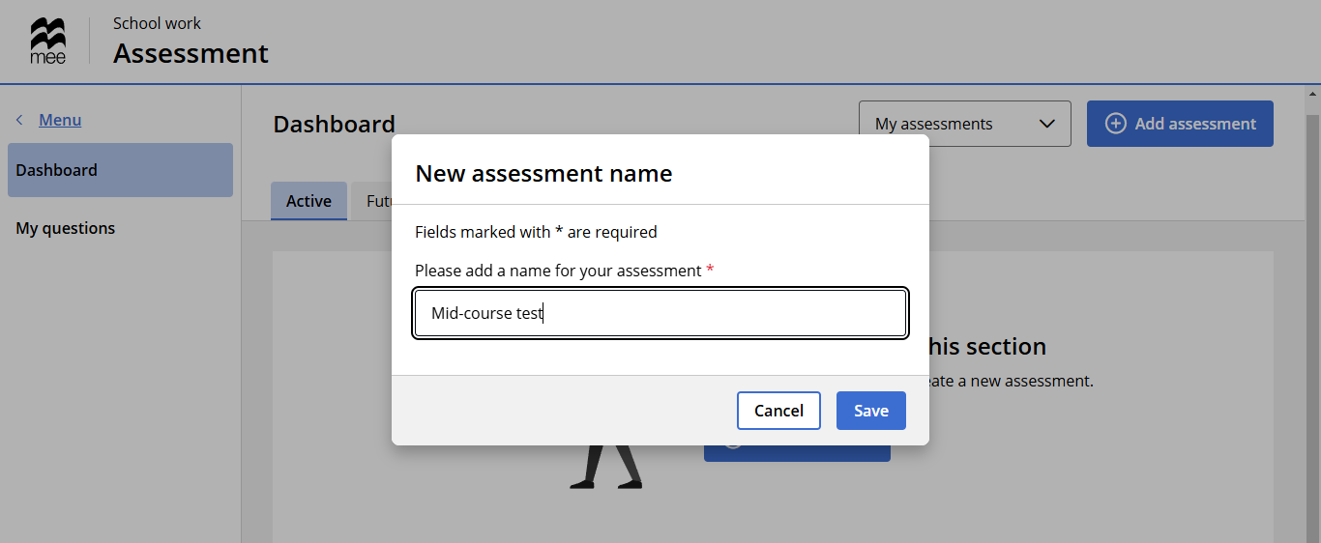
- Click on Add and choose Ready-made tests
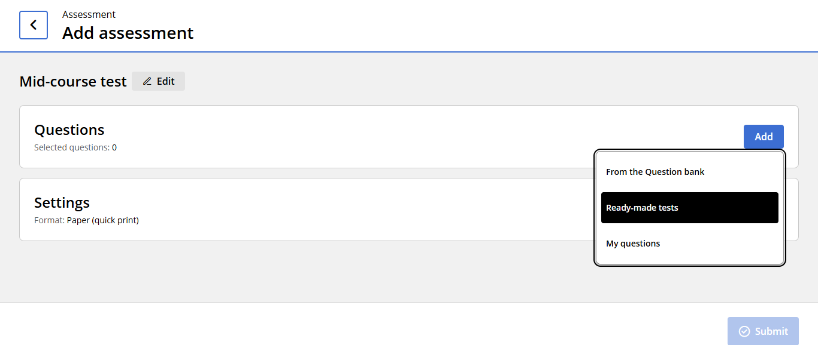
- Choose which test you want to print (Unit tests, Mid-course tests or End-of-course tests)
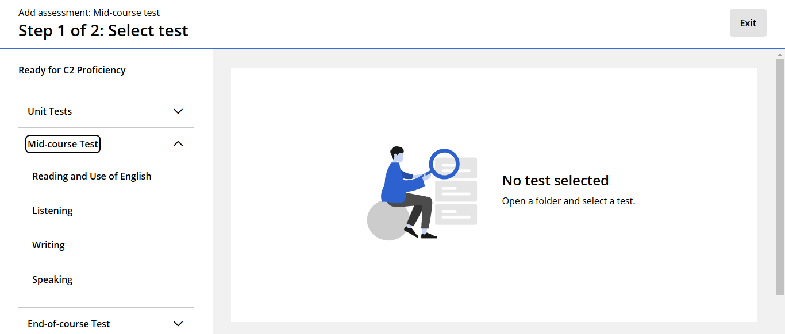

- Choose from the drop-down list which type of exercise you want to do
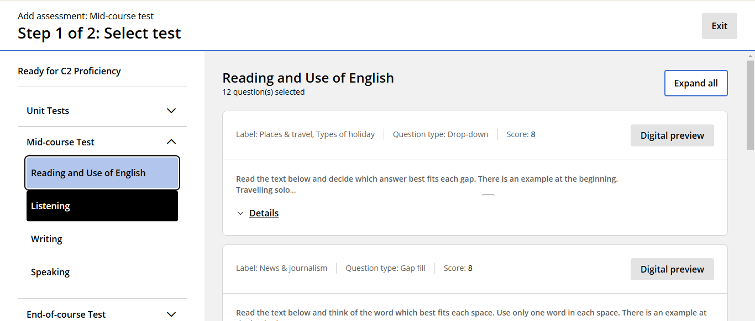

- Scroll to the end of the page and click on Review questions
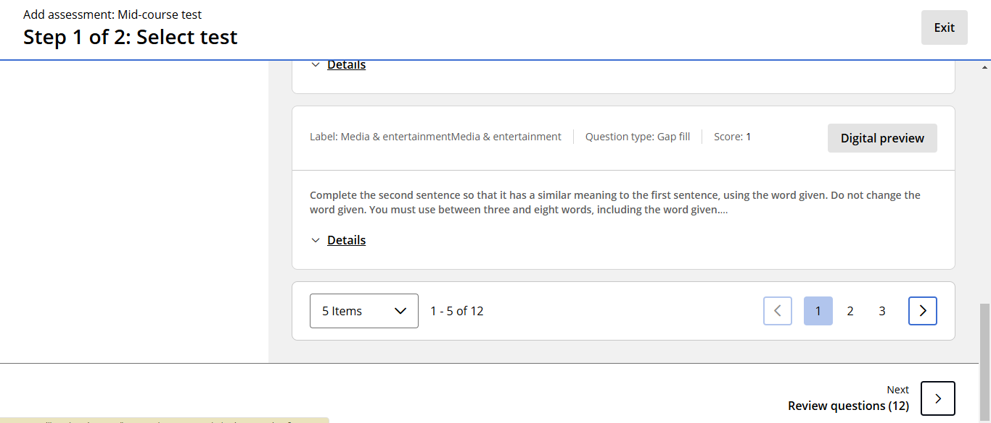

- In the next step, you can remove exercises you do not want to include or continue
- Once you have organized the exercises, scroll to the end and click on Done
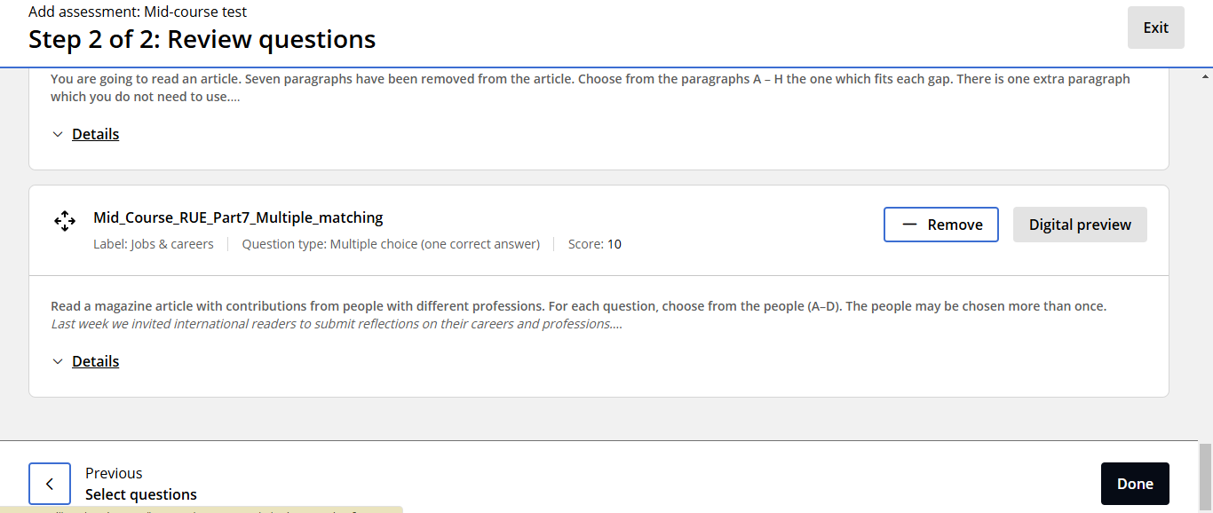
- Click on Add
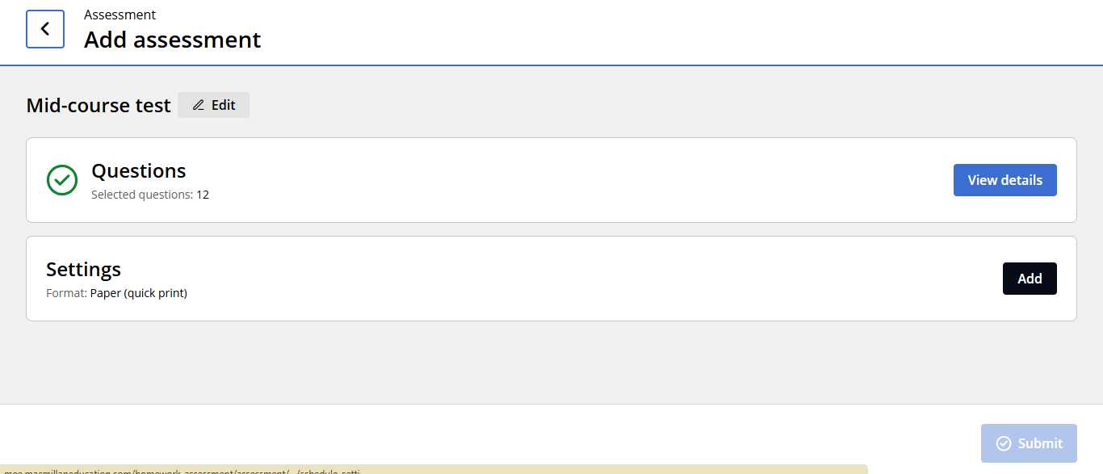

- Click on Done
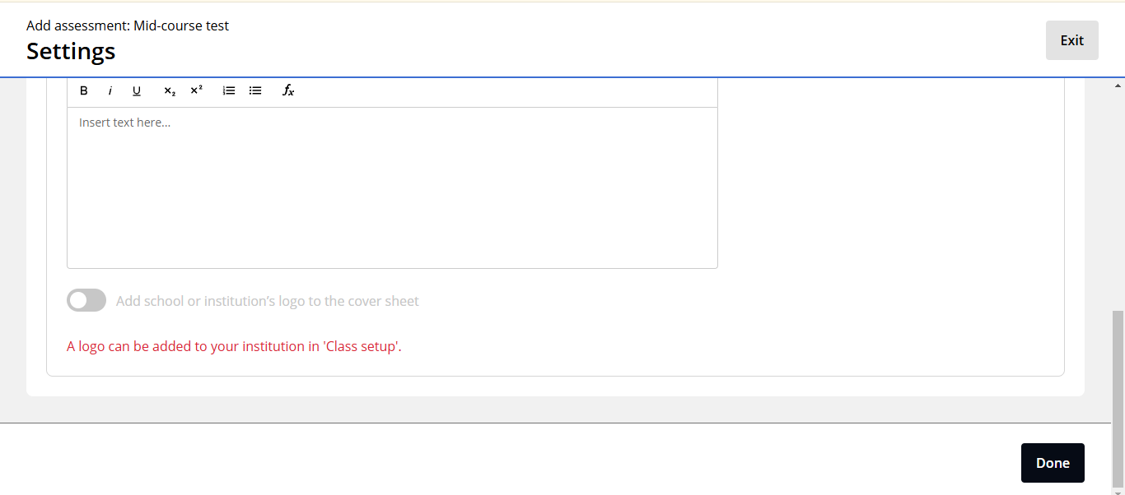
- Click on Submit
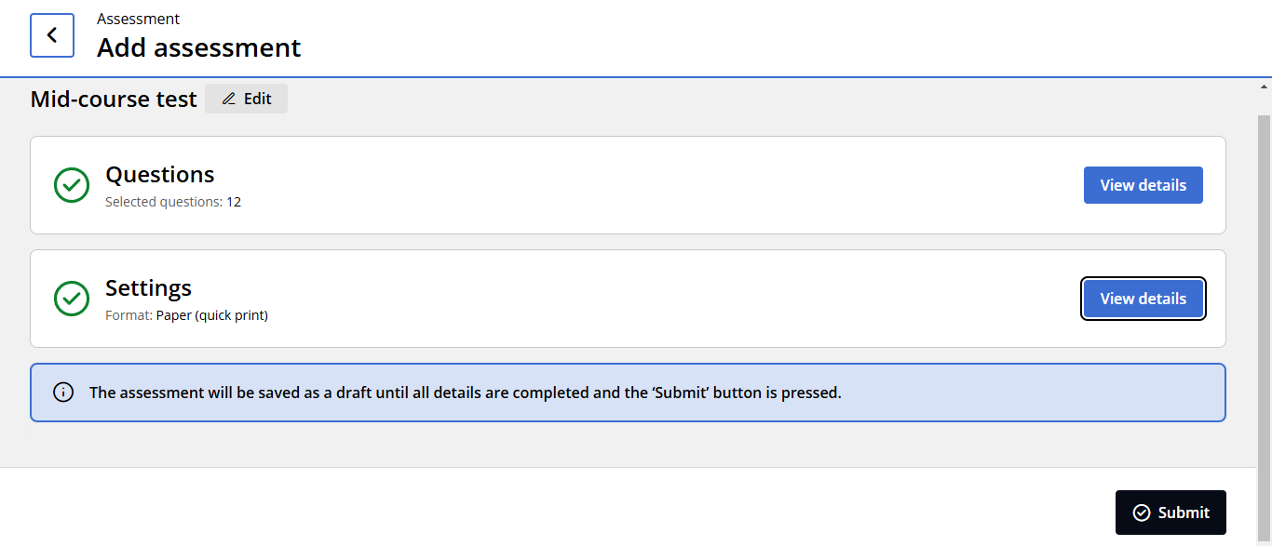
- Wait until the test is generated
- Click on Download
